Knoppix is an ISO image for Linux that may be launched straight from a bootable CD or USB stick; no installation of the software is necessary on the host. It’s a beneficial tool for system repair, data recovery, network analysis, and general computing.
With its comprehensive office suite containing applications such as LibreOffice, providing users with word processing, spreadsheet, presentation, and database management tools. To accommodate varying tastes, the ISO includes text editors like Vim, Nano, and Leafpad, catering to different preferences for coding or general text editing.
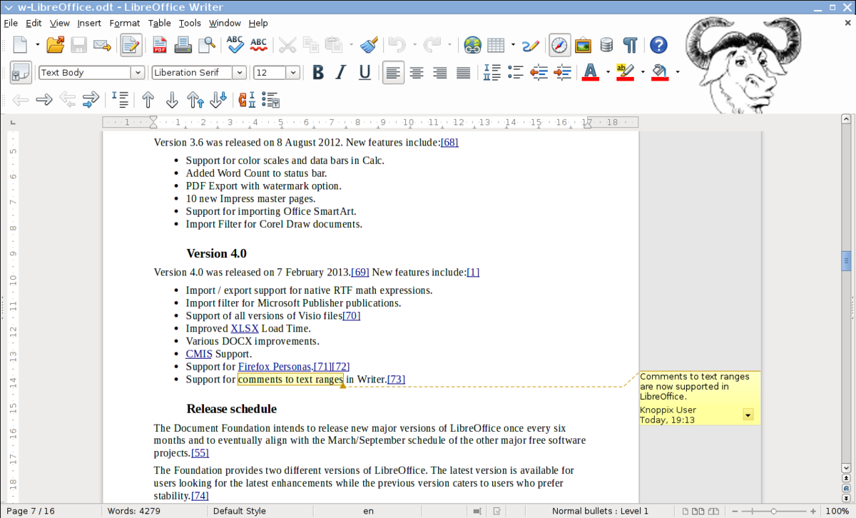
The Chromium and Firefox browsers come preinstalled on it. These browsers have plugins and extensions to improve the browsing experience and guarantee websites work properly.
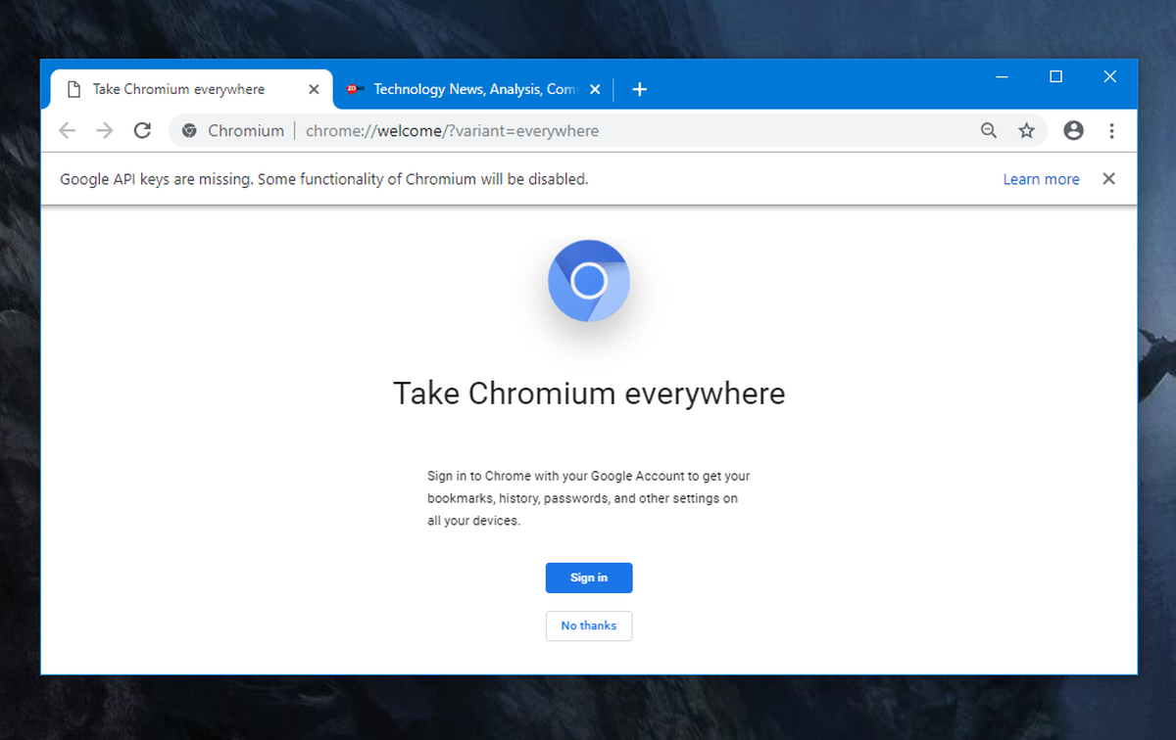
A network protocol analyzer called Wireshark Wireshark is included for capturing and inspecting data packets in real-time. This tool can be used to diagnose network issues, analyze traffic, and detect security breaches. Nmap, a network scanning tool, allows packet inspection and capture.
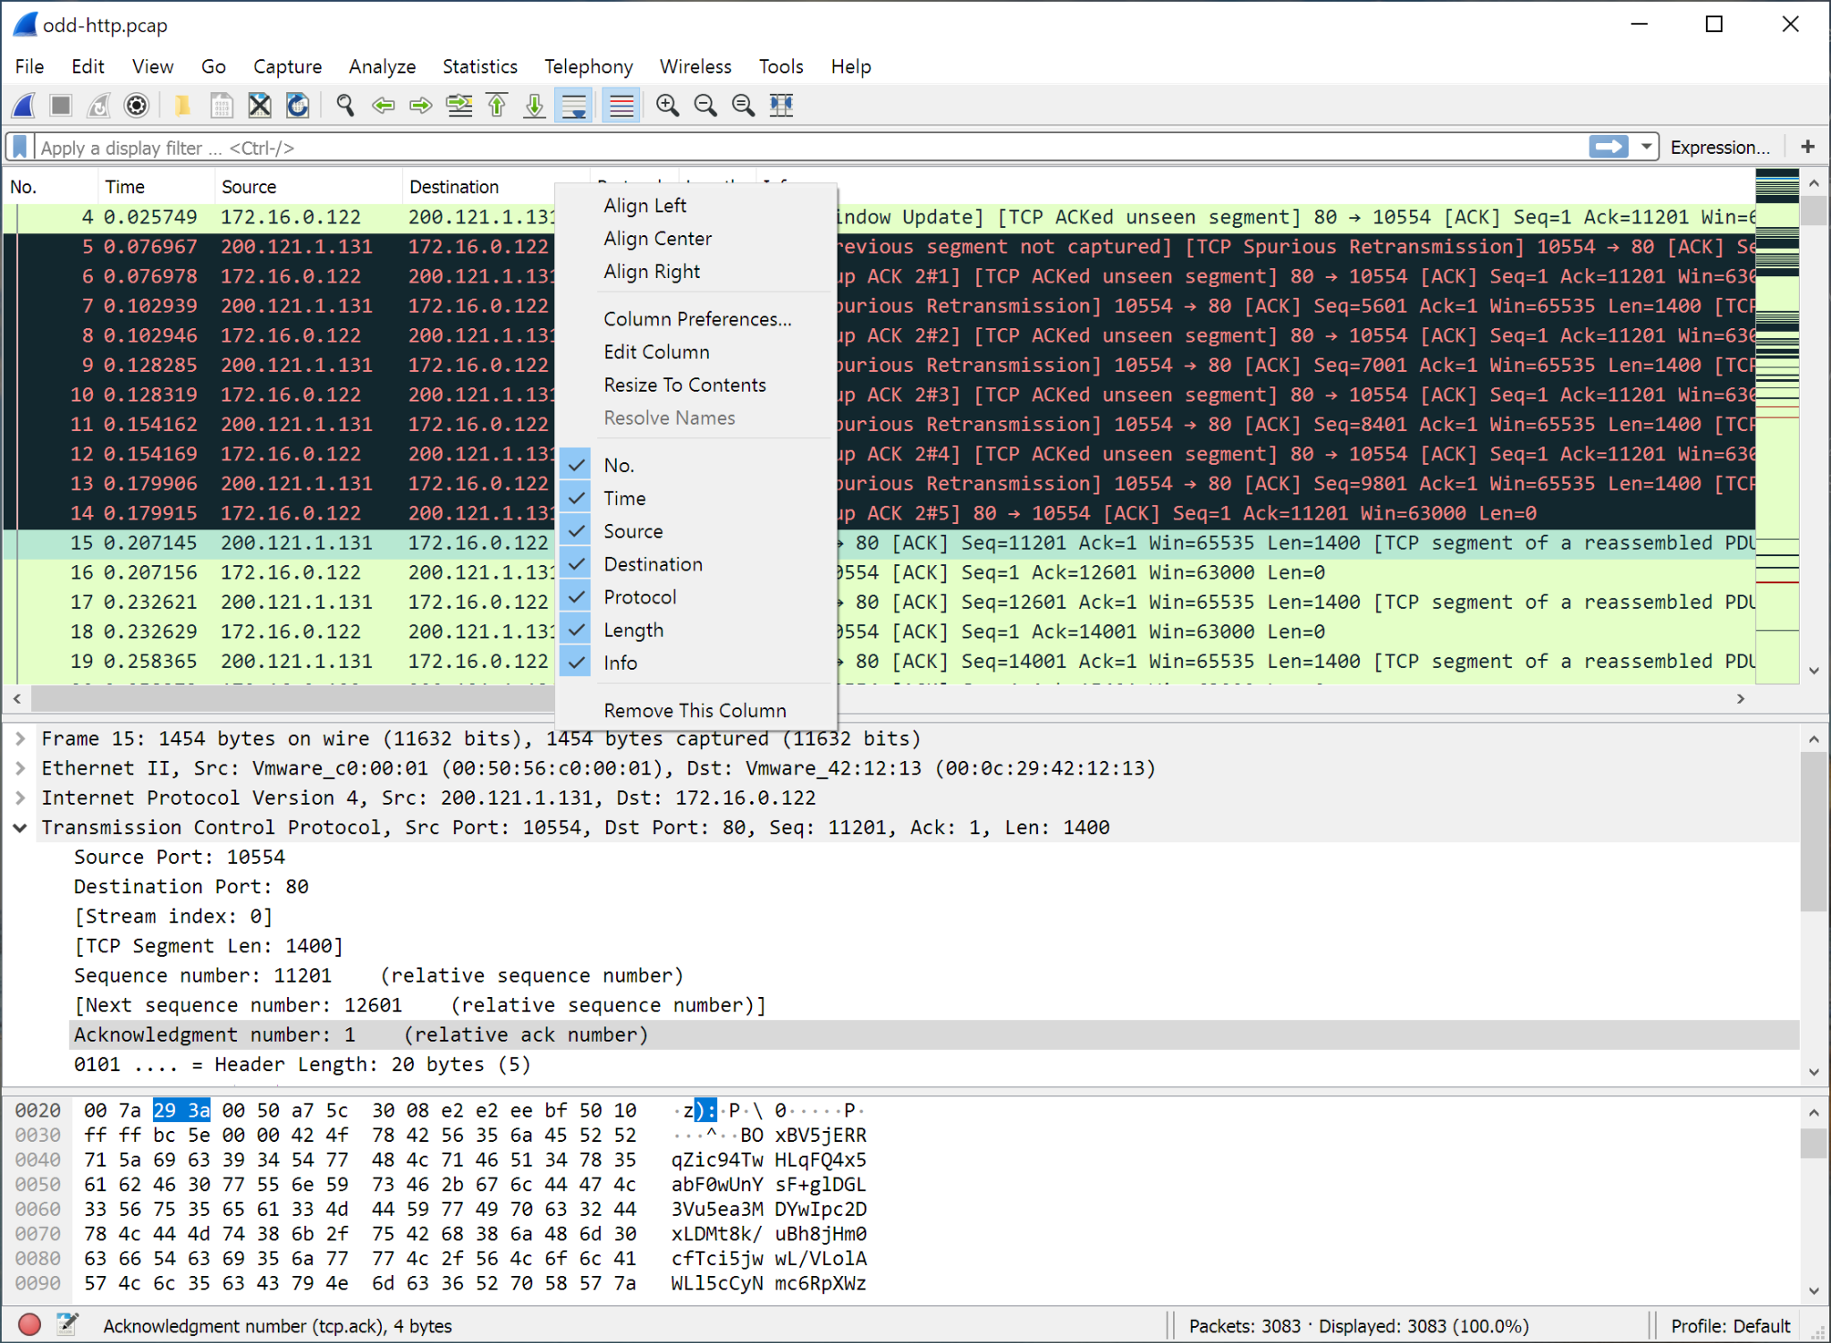
Disk management tools like GParted partition editor let users format, create, and resize partitions on their drives. This is helpful for managing disk space or for a new drive installation. The Clonezilla imaging program, which may be used to clone hard drives or make system backups, is also included with Knoppix.
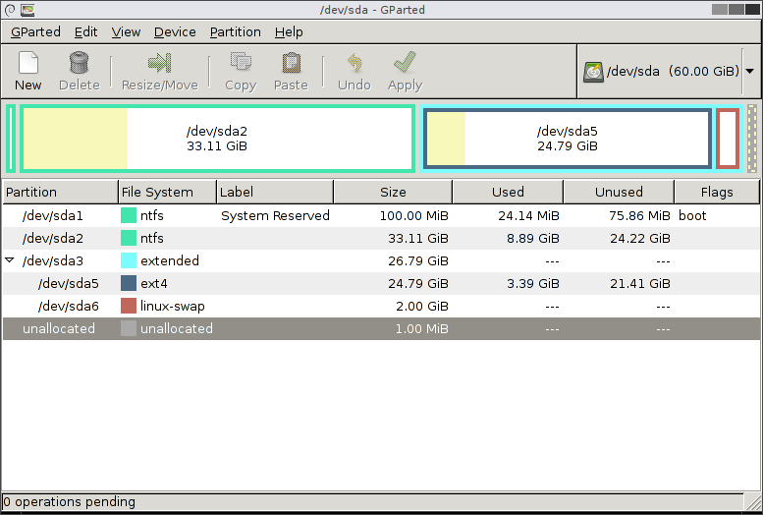
For security and forensic analysis, Knoppix is equipped with tools like John the Ripper and Chntpw. A password-cracking tool called John the Ripper is used to find forgotten or weak passwords and test their strength. Chntpw, on the other hand, allows users to reset Windows passwords, giving them access to their computers again without having to reinstall the operating system on them. These tools are critical for security professionals conducting penetration testing or forensic investigations.
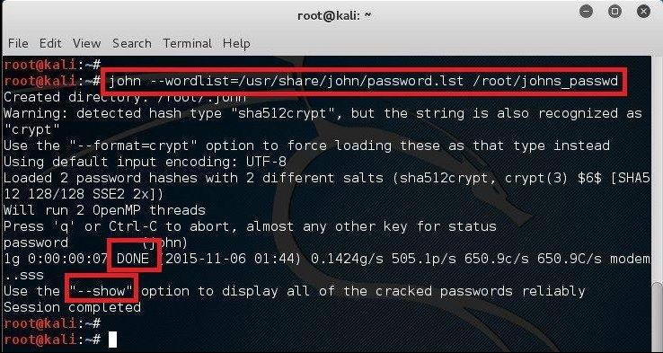
Compilers for a number of programming languages are available on Knoppix, including Python, Perl, and GCC (GNU Compiler Collection) for C and C++. It also comes with version control systems like Git which enables developers to manage their source code repositories.
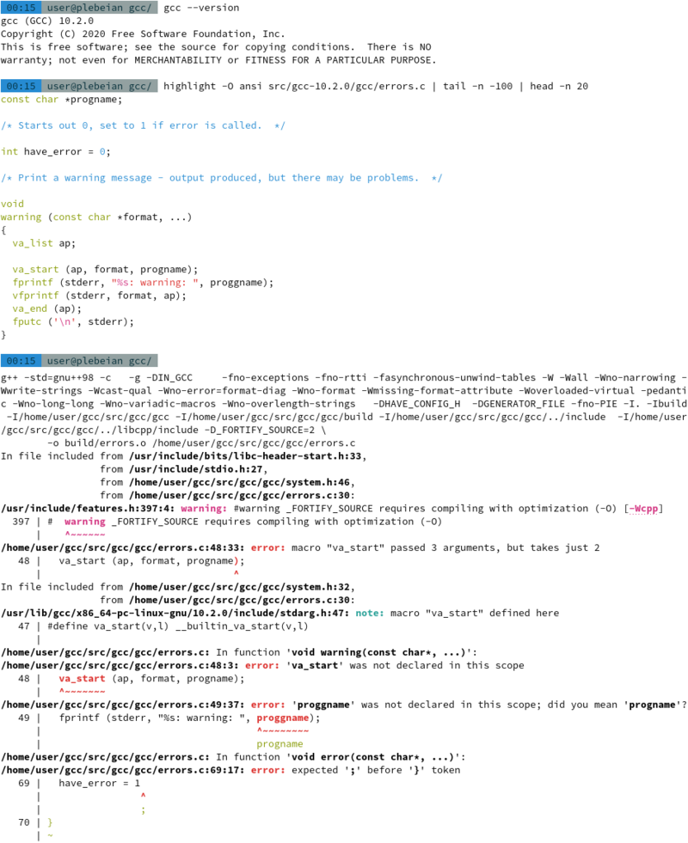
For multimedia capabilities, it includes VLC Media Player, a versatile media player that can handle almost any audio or video format. For audio editing, Audacity is preinstalled, offering recording and editing of audio files. For image editing, it comes with GIMP, an image editing program similar to Adobe Photoshop.
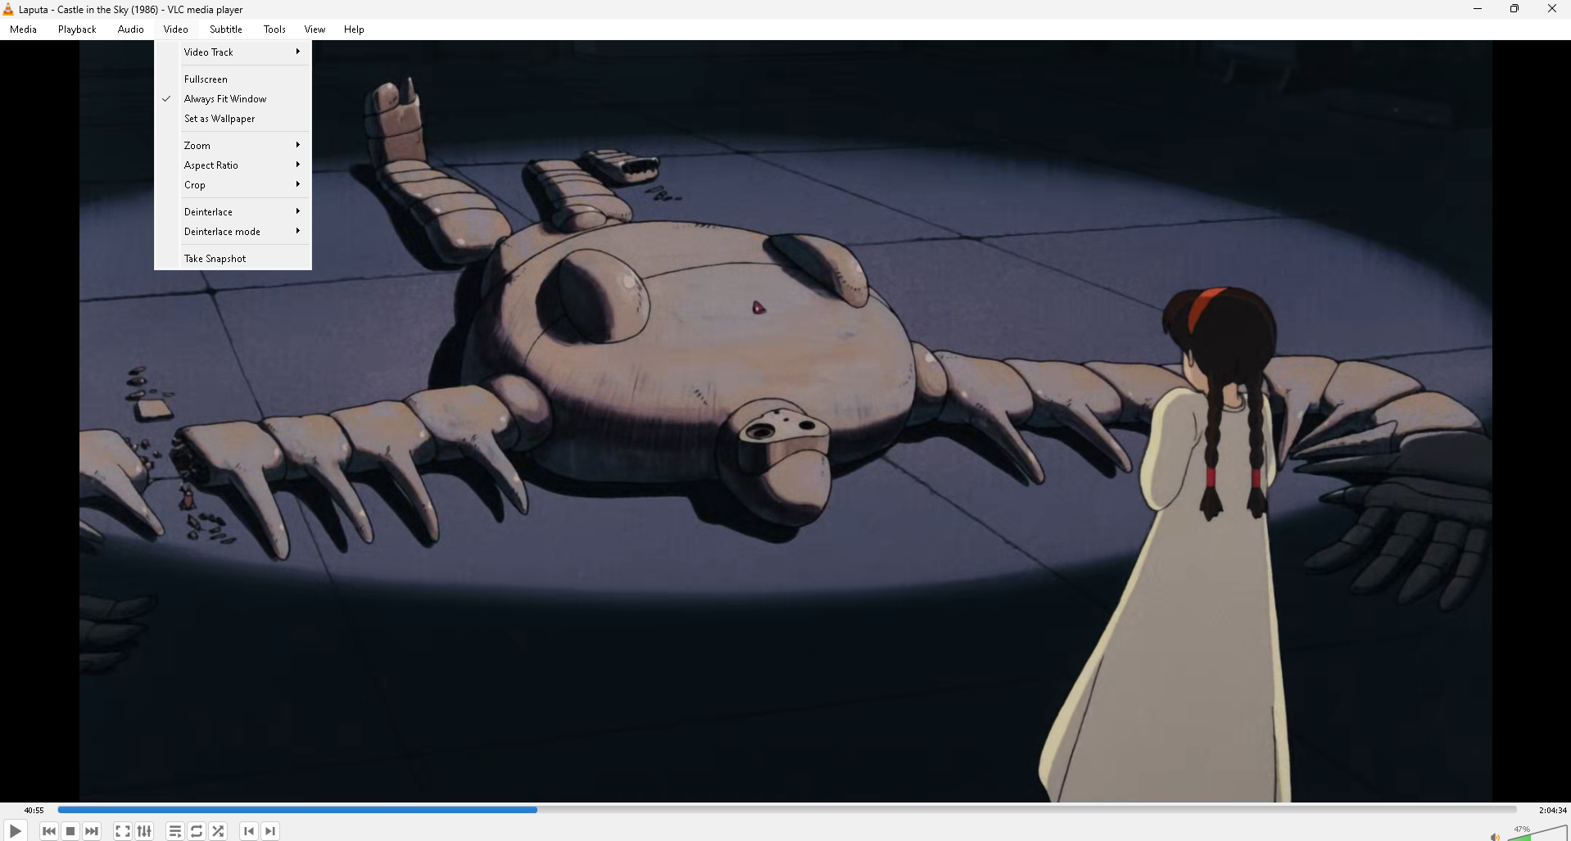

BACKUP INFORMATION
For multimedia capabilities, it includes VLC Media Player, a versatile media player that can handle almost any audio or video format. For audio editing, Audacity is preinstalled, offering recording and editing of audio files. For image editing, it includes GIMP which is comparable to Adobe Photoshop.
THE NEXT SENTENCE NEEDS A TAB.
Data recovery is another area where Knoppix excels. It comes with tools like TestDisk and PhotoRec. TestDisk is designed to recover lost partitions and repair boot sectors, making it invaluable for rescuing data from damaged or corrupted drives. PhotoRec is a file recovery tool that can recover files from a wide variety of file systems, including those used by digital cameras, making it a go-to tool for retrieving lost photos and documents.
THE NEXT SENTENCE NEEDS A TAB.
For users who need to work with encrypted files or drives, Knoppix includes tools like TrueCrypt and VeraCrypt. These tools allow users to create encrypted containers or encrypt entire drives, ensuring that sensitive data remains secure. These encryption tools are essential for anyone dealing with confidential information or concerned about privacy.
THE NEXT SENTENCE NEEDS A TAB.
The Knoppix ISO also includes several system monitoring tools, such as HTOP and Conky. HTOP is an interactive process viewer that provides a real-time overview of system processes, resource usage, and system load. It is particularly useful for identifying processes that are consuming too much CPU or memory. Conky, on the other hand, is a lightweight system monitor that displays system information on the desktop, including CPU usage, memory usage, and network activity. These tools are helpful for keeping track of system performance and diagnosing potential issues.
THE NEXT SENTENCE NEEDS A TAB.
In addition to these tools, Knoppix includes a variety of utilities for managing and troubleshooting hardware. For example, HardInfo provides detailed information about the hardware components of the system, including the CPU, motherboard, and network interfaces. Lshw is another hardware listing tool that gives a more detailed report of the system's hardware configuration, which is particularly useful for system audits or troubleshooting hardware compatibility issues.
THE NEXT SENTENCE NEEDS A TAB.
Knoppix also supports virtualization through tools like QEMU and VirtualBox, which allow users to create and manage virtual machines. This is particularly useful for testing new operating systems or running applications in an isolated environment without affecting the host system. Virtualization tools are essential for developers and IT professionals who need to test software or simulate different computing environments.
THE NEXT SENTENCE NEEDS A TAB.
Lastly, Knoppix includes a host of utilities for general file management and system maintenance. The Midnight Commander file manager provides a text-based interface for navigating the file system, while Rsync is included for efficient file synchronization and backup. These tools, along with the comprehensive suite of applications and utilities mentioned, make Knoppix an incredibly powerful and versatile distribution suitable for a wide range of tasks.
THE NEXT SENTENCE NEEDS A TAB.
In conclusion, the Knoppix ISO image is packed with a broad spectrum of preinstalled tools, ranging from office applications and web browsers to network analysis, system administration, security, development, multimedia, and data recovery tools. Whether used for everyday computing, system repair, or specialized tasks like forensic analysis and network troubleshooting, Knoppix offers a comprehensive set of tools that cater to both casual users and IT professionals. Its ability to run from a live CD or USB without installation makes it a go-to distribution for situations where quick access to a reliable and fully-featured operating system is needed.

Project 3 Capturing Data Images and Extracting Information

INSTRUCTIONS
Download the Knoppix ISO image (CD or DVD) from
http://www.knopper.net/knoppix/index-en.html, and
burn a disk with the image. Boot a PC using the live image
on the CD. Examine the software preinstalled on the image,
and, using the main files on the image and Internet search
engines, list the tools that come preinstalled with the
Knoppix image and what they do. Include screenshots of the
tools. Make the list no more than five pages with screen
shots.
SUBMITTING YOUR PROJECT
Follow this procedure to submit your project online:
1. Log on to the Penn Foster site, and go to the student portal.
2. Click Take Exam next to the lesson you’re working on.
The exam number for this project is 44581900.
3. Attach your file or files as follows:
a. Click the Browse box.
b. Locate the file you wish to attach.
c. Double-click on the file.
d. Click Upload File.
4. Enter your e-mail address in the box provided. This
information is required for online submission.
5. If you wish to tell your instructor anything specific
regarding this assignment, enter it in the Message box.
6. Click Submit File.

GRADING CRITERIA
Your instructor will use the following criteria in grading your
project:
• The paper outlines a list of tools
and applications presently available
on the Knoppix image. 25 points
• The paper includes screen shots of
at least two current tools included
on the Knoppix image. 25 points
• The paper includes a brief explanation
of what each tool does (listing the
primary function is acceptable). 50 points
• Total: 100 points

